**Assignment – User Management**

1. Create user "nikhil" with home directory set as "/home/nikhil"

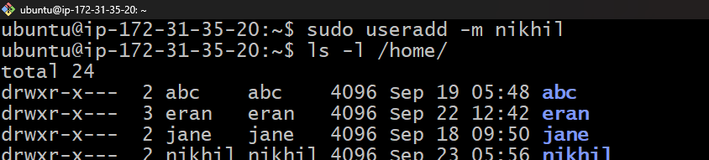

1. nikhil user should have "/bin/sh" shell for his environment

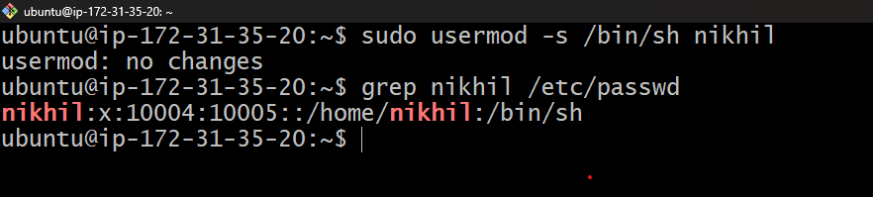

**b)** His password should expire in 9 days and 2 days before password expiry, he

should get warning. User account must expire in 1 month from creation date

**step 1 :- sudo chage -M 9 nikhil**

**step 2 :- sudo chage -W 2 nikhil**

1. Give him root privileges to start/stop cron daemon.

**2)** Inside folder "/" , create new home directory as "nikhil" (/nikhil) and setup this folder

as a home directory for user "nikhil"

**step1 :- su Nikhil**

**step2 : - mkdir /Nikhil**

**step3 :- sudo chown 700 /nikhil**